SAVEETHA SCHOOL OF ENGINEERING
CSA15- CLOUD COMPUTING AND BIG DATA ANALYTICS
LIST OF EXPERIMENTS 4
EDRIN J S
192524041
4. Build a basic cloud-based Car Booking Reservation System using any Cloud Service Provider, in order to demonstrate the SaaS model.
Aim
To design and build a cloud-hosted Car Booking Reservation System built on Zoho Creator and roll it out as a Software as a Service (SaaS) application, so that users can reserve, manage, and track car bookings over the internet.

Procedure
- Sign in to Zoho Creator with a valid Zoho account.
- Start a new application called Car Booking Reservation System.
- Build the following forms:
  - Customer Information
  - Car Information
  - Booking Details
- Include the necessary fields such as Customer Name, Contact Number, Email, Car Model, Registration Number, Pickup Location, Drop-off Location, Booking Date, Return Date, Rental Cost, and Booking Status.
- Set up reports that show available cars, booking history, and customer information.
- Set up workflows that handle booking confirmation, check availability, and validate entered data.
- Define user roles and permissions for administrators and customers.
- Publish the completed application on the Zoho Creator cloud platform.
- Verify the application by adding cars, making reservations, updating booking details, and viewing reports through a web browser.

Snapshots:
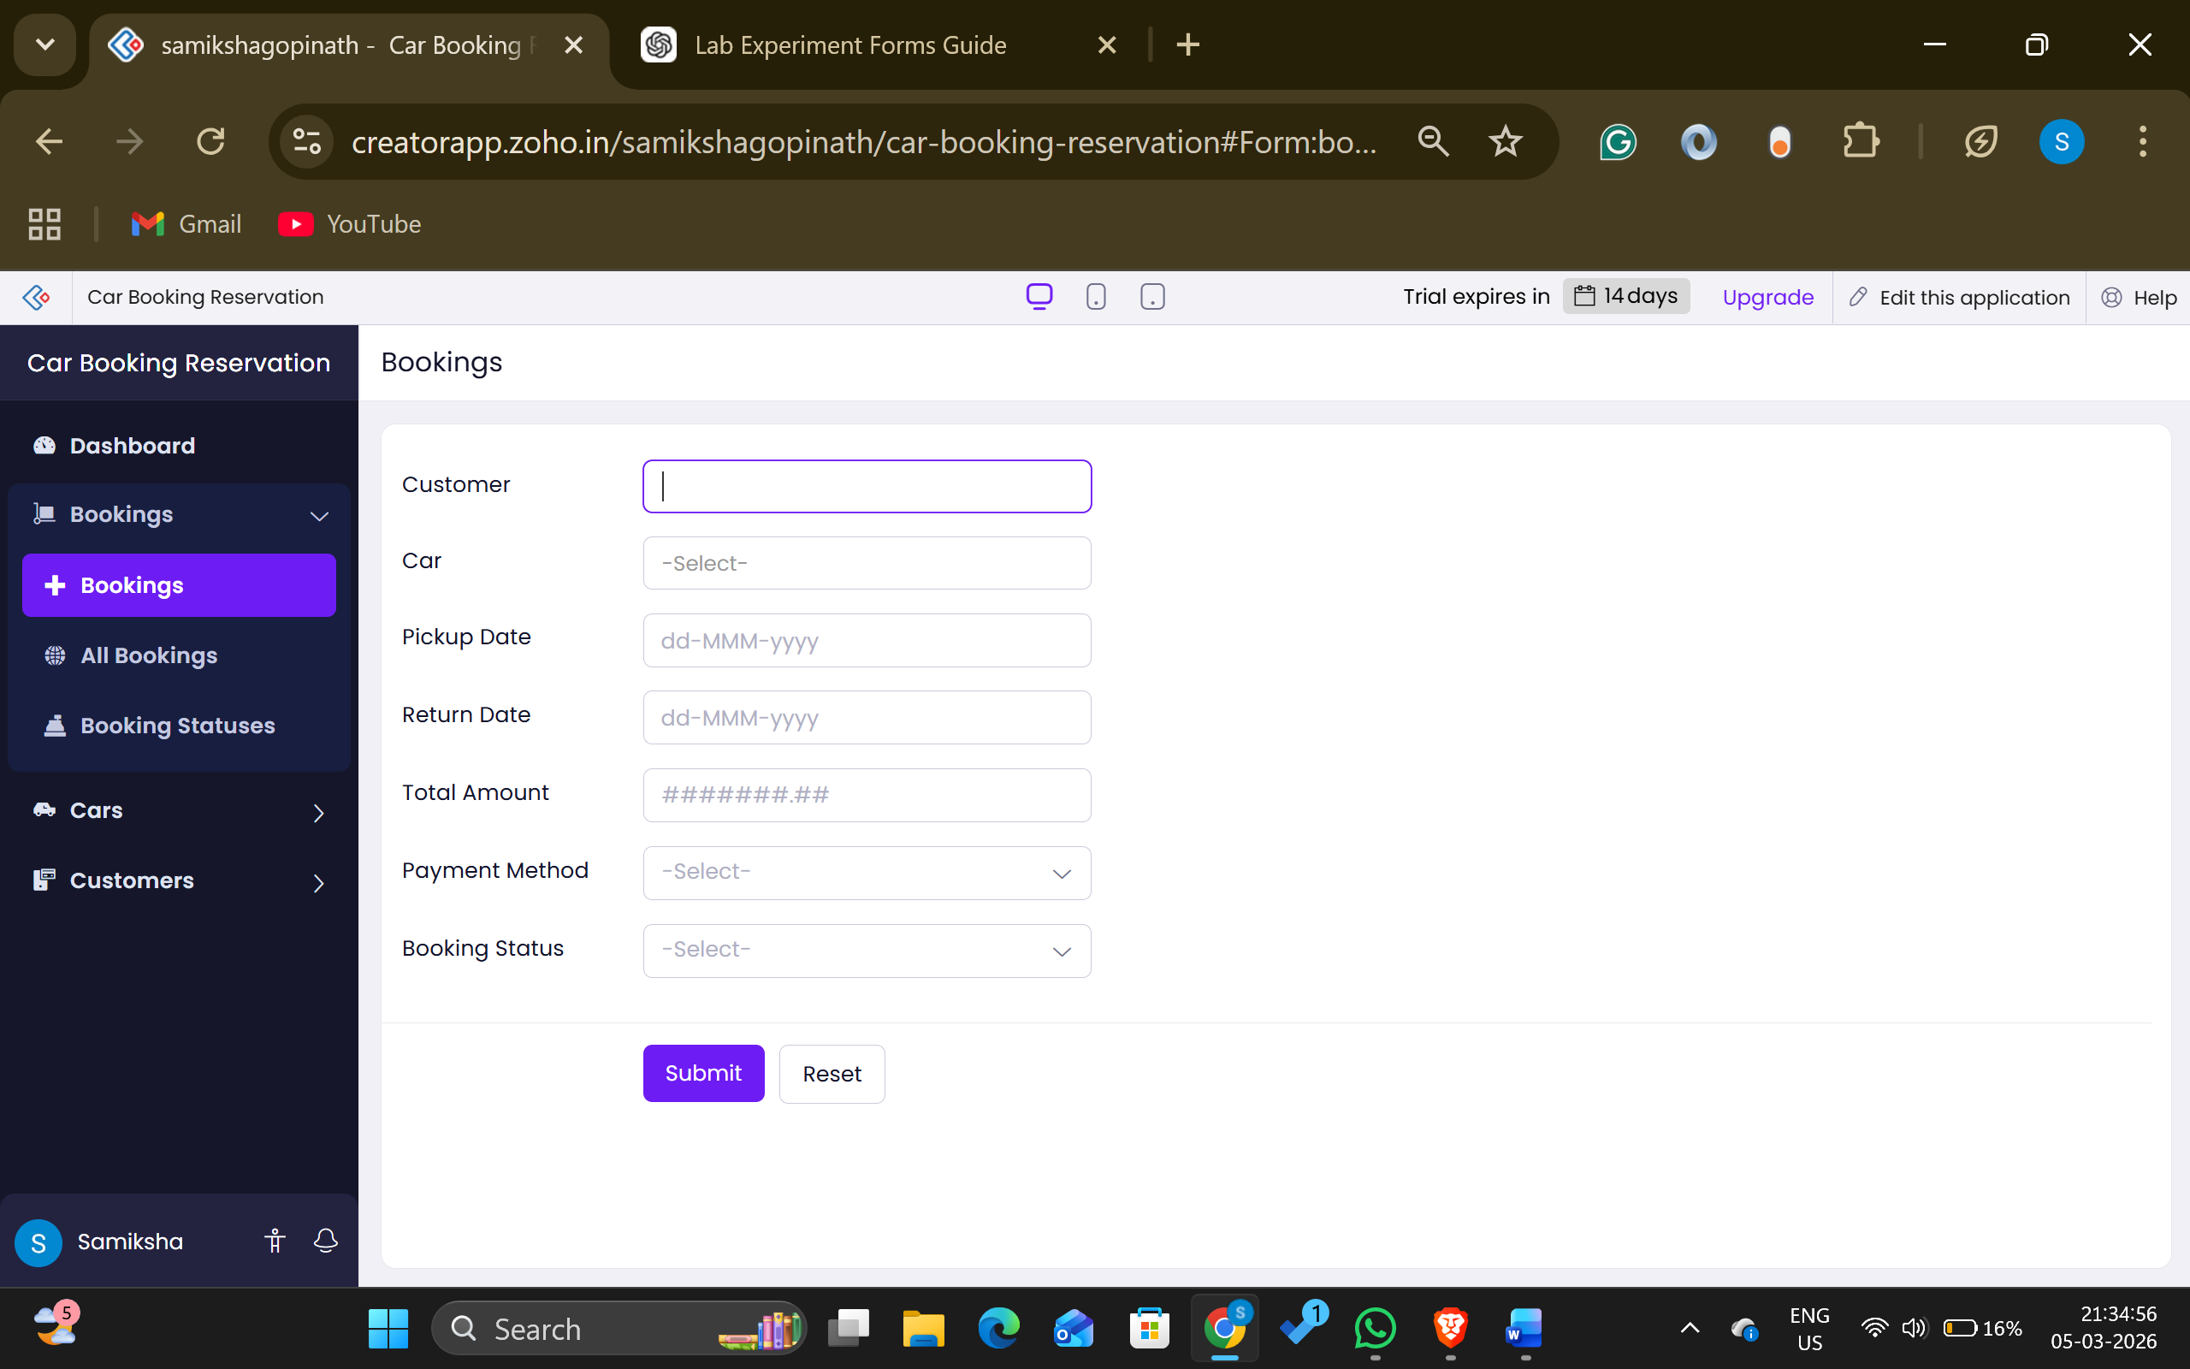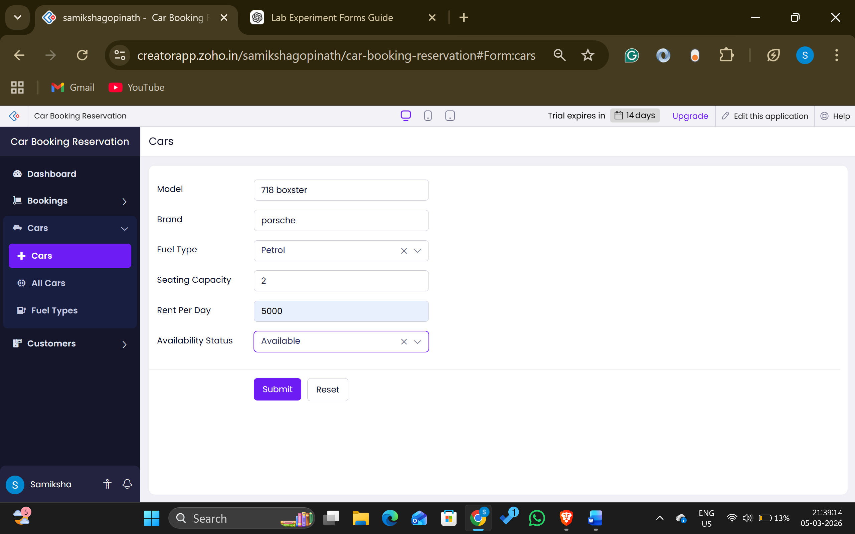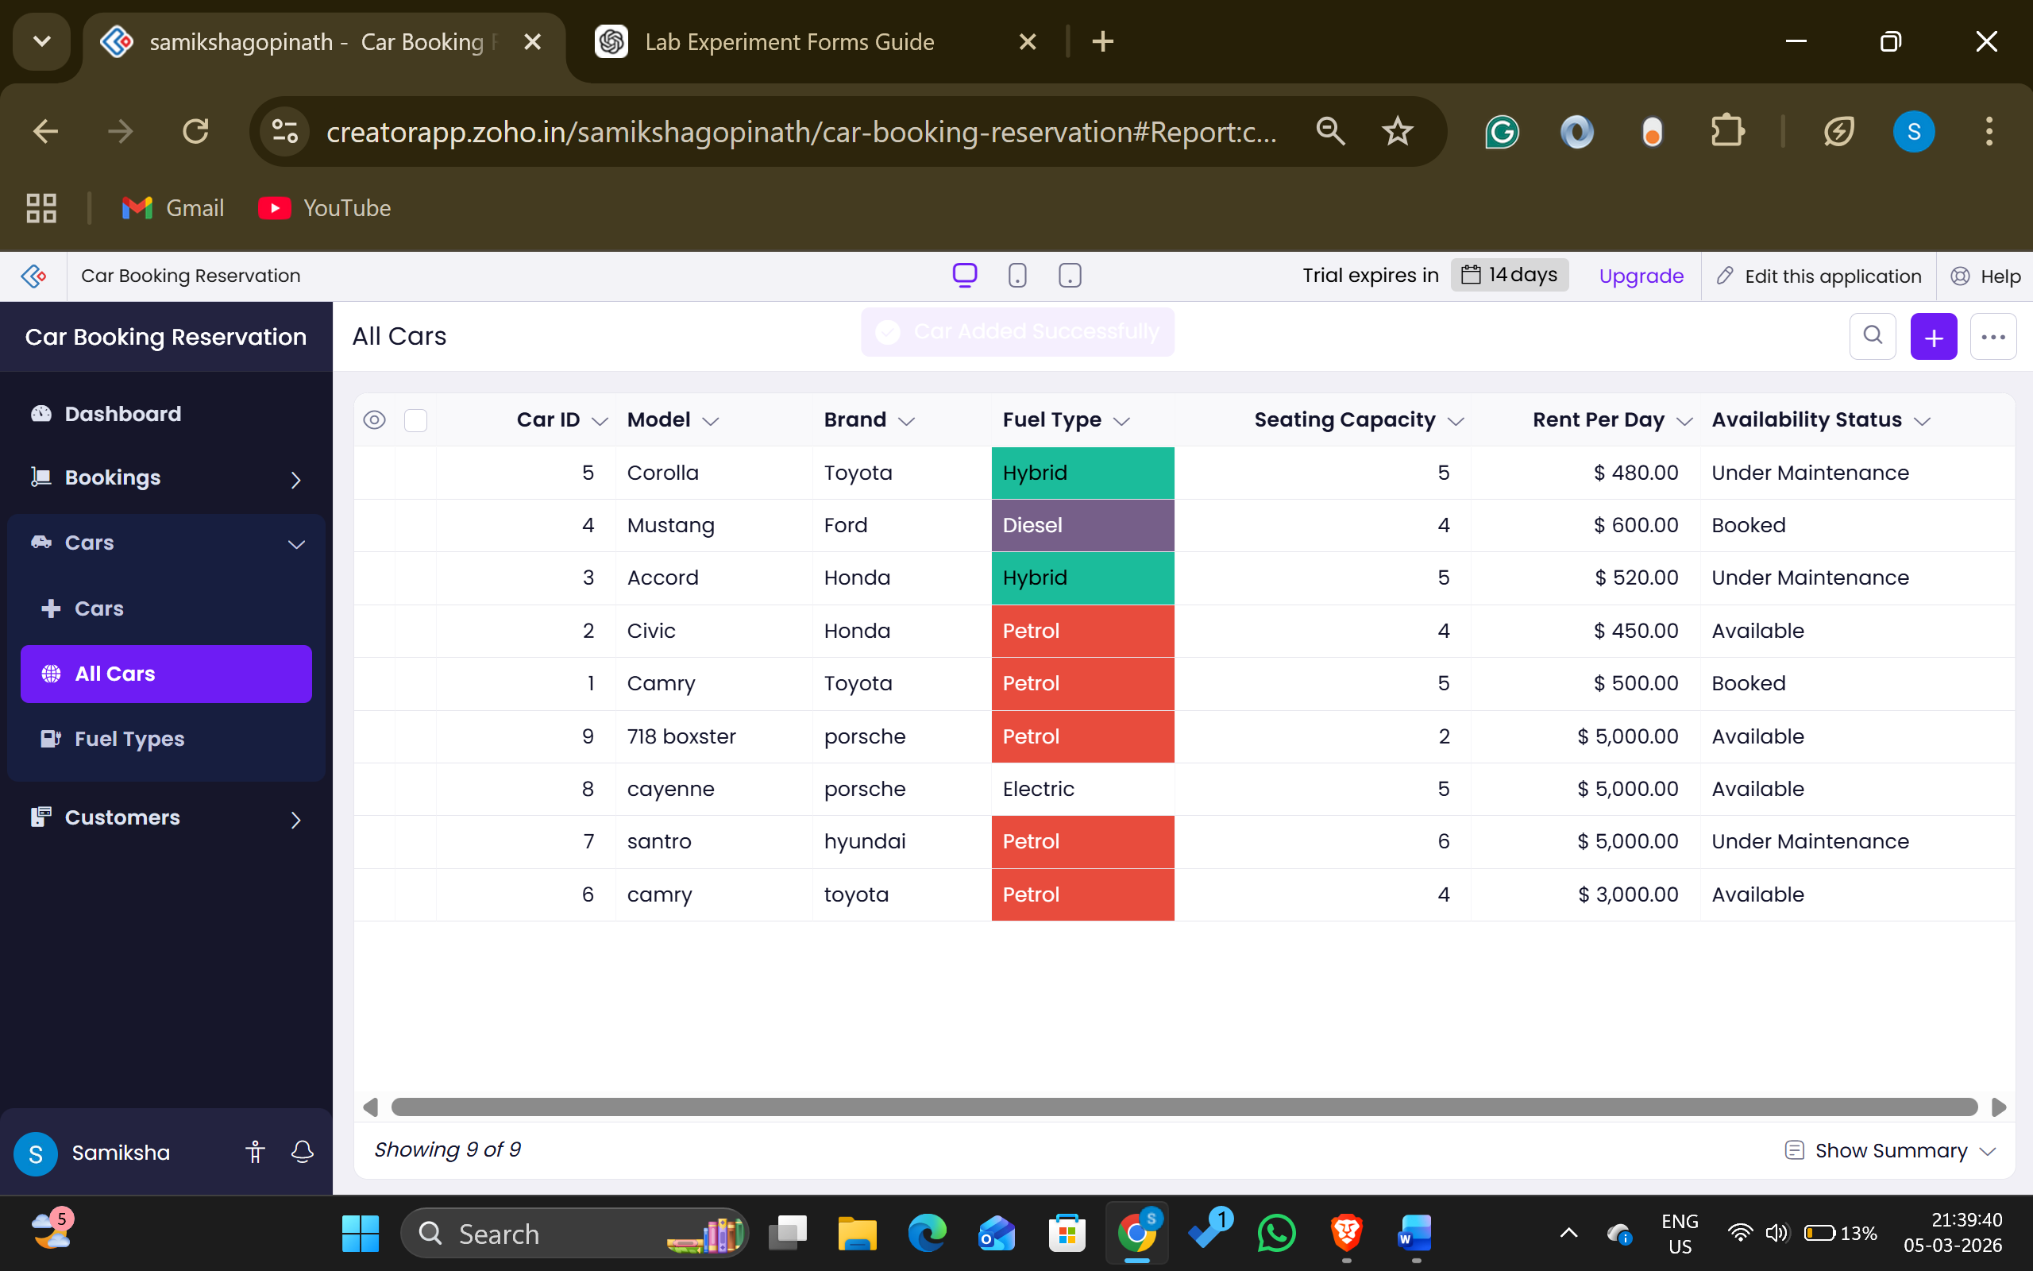
Result
A cloud-hosted Car Booking Reservation System was successfully built and deployed using Zoho Creator. Users were able to reserve and manage car bookings online through a web browser, confirming the Software as a Service (SaaS) model by offering secure access from anywhere, at any time, with no local installation needed

